Examination Paper for《Introduction to Artificial Intelligence》
Example
No. of  Items | Part I | Part II | Part III | Part IV | Part Ⅴ | Part Ⅵ | Part Ⅶ | Total | Signature of the  Examiner
Points

PartⅠ、Some easy questions to start with（12 pts.）
1、(2) True/false: Suppose that variables 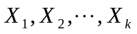 have no parents in a given Bayes net that contains variables in all, where 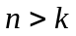. Then the Bayes net asserts that

2、(2) True/false: In a fully observable, turn-taking, zero-sum game between two perfectly rational players, it does not help the first player to know what move the second player will make.

3、(2) True/false: A* search cannot be used in robotics because percepts, states, and actions are continuous.

4、(2) True/false: Reinforcement learning is a specific supervised learning method.

5、(2) True/false: A discrete function can be represented as a decision tree.

6、(2) True/false: The ‘population’ in evolutionary computation is the same as that in swarm intelligence.

Part II、Search（14 pts.）
For 8-puzzle problem, the initial state S0 and the goal state Sg are shown in the following Figures:
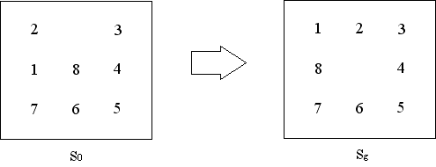
Use A* algorithm to solve this problem. Label the value of h(n) and f(n) for each node.
（The heuristic function is the number of misplaced tiles）

Part III、Game（14 pts.）
Given the following search tree, apply the alpha-beta pruning algorithm to it, proceeding with a Left to Right expansion of the nodes. Make sure that you label all the backed-up values of and  beside the corresponding nodes, and show which parts of the search tree are pruned as a result.
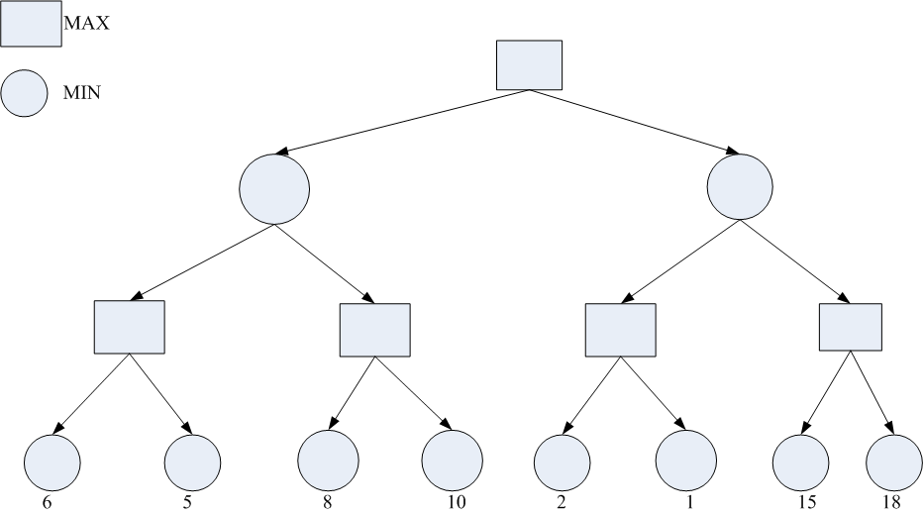

Part IV、First-Order Logic（15 pts.）
Translate into the first-order logic the following sentences:
1、(3) Every gardener likes the sun.

2、(3) No student buys an expensive car.

3、(3) Every person who learns artificial intelligence learns philosophy.

4、(3) Every cat loves its mother or father.

5、(3) If someone understand someone, then he is that someone’s friend.

Part Ⅴ、Logic Inference (15 pts.)
Zhang was stolen. Five detectives were assigned to investigate this case. When they discussed the case, the detective A said: “Either Zhao or Qian must be the thief.”; the detective B said: “Either Qian or Sun must be the thief.”; the detective C said: “Either Sun or Li must be the thief.”; the detective D said: “Either Zhao or Sun must not be the thief.”; the detective E said: “Either Qian or Li must not be the thief.”. Suppose the words of five detectives are true. Please prove Sun is the thief using the resolution inference rule.

Part Ⅵ、Learning (15 pts.)
Consider the problem of deciding whether or not to play tennis, based on the attributes of rain and wind of the morning in question. Here is a set of training examples.
Example | PlayTennis | Wind | Rain
1 | false | True | False
2 | false | True | True
3 | true | False | True
4 | false | False | False
5 | true | True | False
6 | true | True | True
According to the information gain, which attribute will be chosen as the root of the decision tree learned from these examples? (Hint: 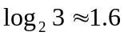)

Part Ⅶ、Clustering (15 pts.)
Given a set of data: {3.6，9，28，52，4.7，6.2，40，16，22.5}, use k-means clustering algorithm to divide these data into three clusters. (The first three data are taken as the initial cluster means)

